Indefinite Pronouns

🔹 What Are Indefinite Pronouns?
# Source: AI Source: Provided by: [Data Path: Persons Table -> ID Column: 1, Name_En Column: Motasem Essam] -> From: [Chatgpt (GPT-4-turbo)] on [7/27/2025]
Indefinite pronouns refer to non-specific people or things.
They do not refer to anyone or anything in particular — the subject is "indefinite" or "unknown."

✅ Common Indefinite Pronouns

🔸 Referring to people
# Source: AI Source: Provided by: [Data Path: Persons Table -> ID Column: 1, Name_En Column: Motasem Essam] -> From: [Chatgpt (GPT-4-turbo)] on [7/27/2025]
- everyone, everybody
- someone, somebody
- anyone, anybody
- no one, nobody

🔸 Referring to things
# Source: AI Source: Provided by: [Data Path: Persons Table -> ID Column: 1, Name_En Column: Motasem Essam] -> From: [Chatgpt (GPT-4-turbo)] on [7/27/2025]
- everything
- something
- anything
- nothing

🔸 Others
# Source: AI Source: Provided by: [Data Path: Persons Table -> ID Column: 1, Name_En Column: Motasem Essam] -> From: [Chatgpt (GPT-4-turbo)] on [7/27/2025]
- each, either, neither
- all, some, many, few, several, none, one, both

📚 Examples in Sentences
# Source: AI Source: Provided by: [Data Path: Persons Table -> ID Column: 1, Name_En Column: Motasem Essam] -> From: [Chatgpt (GPT-4-turbo)] on [7/27/2025]
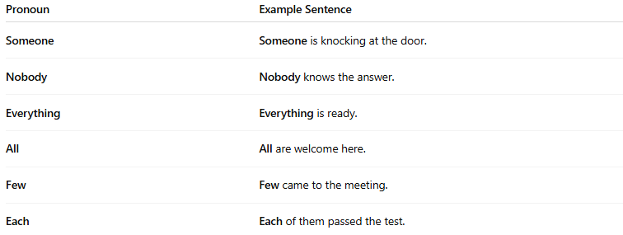
Pronoun | Example Sentence
Someone | Someone is knocking at the door.
Nobody | Nobody knows the answer.
Everything | Everything is ready.
All | All are welcome here.
Few | Few came to the meeting.
Each | Each of them passed the test.

🧠 Grammar Tip
# Source: AI Source: Provided by: [Data Path: Persons Table -> ID Column: 1, Name_En Column: Motasem Essam] -> From: [Chatgpt (GPT-4-turbo)] on [7/27/2025]
Some indefinite pronouns are singular, some are plural, and some can be both depending on context.
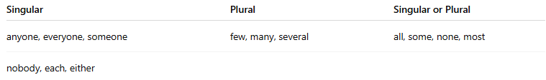
Singular | Plural | Singular or Plural
anyone, everyone, someone | few, many, several | all, some, none, most
nobody, each, either
🔸 Everyone is happy. (singular)
🔸 Few are here today. (plural)
🔸 Some of the water is gone. / Some of the students are late.

